**DEPARTMENT OF COMPUTER SCIENCE AND ENGINEERING**



**CMR COLLEGE OF ENGINEERING AND TECHNOLOGY**

**(An Autonomous Institution, Approved by AICTE, NAAC ‘A+’)**

Kandlakoya, Medchal Road, Hyderabad-501401

**A Project report on**

##### Telangana Tourist Guide

A Dissertation submitted to JNTU Hyderabad in partial fulfillment of the academic requirements for the award of the degree.

**Bachelor of Technology**

## in

**Computer Science and Engineering**

Submitted by

K.Nithin - 20H51A0513

G.Praneeth - 20H51A0510

P.Tharun - 20H51A0522

Under the esteemed guidance of

J.Ranjith

Assistant Professor

**Department of Computer Science and Engineering**

**CMR COLLEGE OF ENGINEERING & TECHNOLOGY**

(An Autonomous Institution, Approved by AICTE, Affiliated to JNTUH, NAAC ’A+’)

KANDLAKOYA, MEDCHAL ROAD, HYDERABAD - 501401.

**2020- 2024**

#### CMR COLLEGE OF ENGINEERING & TECHNOLOGY

KANDLAKOYA, MEDCHAL ROAD, HYDERABAD – 501401

**DEPARTMENT OF COMPUTER SCIENCE AND ENGINEERING**



**CERTIFICATE**

This is to certify that the Project report **“Telangana Tourist guide”** being submitted by **K.Nithin (20H51A0513), G.Praneeth (20H51A0510), P.Tharun (20H51A0522),** in partial fulfillment for the award of **Bachelor of Technology in Computer Science and Engineering** is a record of bonafide work carried out his/her under guidance and supervision.

The results embodies in this project report have not been submitted in any other university/institute for the award of any degree.

**J.Ranjith Dr. S. Shiva Skandha**

**Assistant Professor Associate Professor and HOD**

**Dept. of CSE Dept. of CSE**

**ACKNOWLEDGEMENT**

With great pleasure We want to take this opportunity to express my heartfelt gratitude to all the people who helped in making this project work a grand success.

We are grateful to **J.Ranjith**,Assistant Professor, Dept of Computer Science and Engineering for his valuable technical suggestions and guidance during the execution of this project work.

We would like to thank **Dr.S.Siva Skandha,**Assosciate ProfessorHead of the Department of Computer Science and Engineering, CMR College of Engineering and Technology, who is the major driving forces to complete my project work successfully.

We are very grateful to **Dr. Vijaya Kumar Koppula**, Dean-Academic, CMR College of Engineering and Technology, for his constant support and motivation in carrying out the project work successfully.

We are highly indebted to **Dr. V A Narayana,** Principal, CMR College of Engineering and Technology, for giving permission to carry out this project in a successful and fruitful way.

We would like to thank the Teaching & Non- teaching staff of Department of Computer Science and Engineering for their co-operation

Finally I express my sincere thanks to **Mr. Ch. Gopal Reddy**, Secretary, CMR Group of Institutions, for his continuous care. I sincerely acknowledge and thank all those who gave support directly and indirectly in completion of this project work.

K.Nithin - 20H51A0513

G.Praneeth - 20H51A0510

P.Tharun - 20H51A0522

**TABLE OF CONTENTS**

| **CHAPTERS** | | **DESCRIPTION** | **PAGE No** |
| --- | --- | --- | --- |
|  |  | Abstract | 6 |
| 1 | 1.1 | Introduction | 7-9 |
| 1.2 | Literature Review | 10 |
| 2 | 2.1 | Existing solutions | 11-12 |
| 2.2 | Proposed solutions | 12 |
| 3 | 3.1 | System design | 13-15 |
| 3.2 | Requirement analysis | 15 |
| 3.3.1 | Hardware requirements | 15 |
| 3.3.2 | Software requirements | 15-25 |
| 4 | 4.1  4.1.1  4.1.2 | Home page  Result  Tourist places | 26  27  27-28 |
| 4.1.3 | Source code | 29 |
| 5 | 5.1 | Conclusion | 30 |
| 5.2 | References | 31 |

**ABSTRACT**

* The ultimate goal of the App is to explore the requirements of travelers in Telangana and our proposed and developed solution of android application including some basic guidance for the travelers in Telangana. Every year thousands of foreigners from diverse
* countries come to visit Telangana for different purposes. Most of them come for religious, study, and business purposes. Besides, tourists also visit different places of natural beauty and history of the country. However, being foreigners, the travelers face different types of problems including limited transportation information, problems in locating nearby hotels and so on. Based on travelers’ requirements, we have come up with our online mobile application which can solve their problem during visiting Hyderabad city of Telangana. The App illustrates the features, development method, result, and uses of our android application named “Tourist Guide”

**CHAPTER-1**

**INTRODUCTION**

**1.1 INTRODUCTION**

Besides, tourists also visit different places of natural beauty and history of the country. However, being foreigners, the travelers face different types of problems including limited transportation information, problems in locating nearby hotels and so on. Based on travelers’ requirements, we have come up with our online mobile application which can solve their problem during visiting Hyderabad city of Telangana. The App illustrates the features, development method, result, and uses of our android application named “Tourist Guide”.

**Appropriate android studio**

Android Studio is the official integrated development environment (IDE) for Android application development. It is based on the IntelliJ IDEA, a Java integrated development environment for software, and incorporates its code editing and developer tools.

To support application development within the Android operating system, Android Studio uses a Gradle-based build system, emulator, code templates, and Github integration. Every project in Android Studio has one or more modalities with source code and resource files. These modalities include Android app modules, Library modules, and Google App Engine modules.

Studio uses an Instant Push feature to push code and resource changes to a running application. A code editor assists the developer with writing code and offering code Android completion, refraction, and analysis. Applications built in Android Studio are then compiled into the APK format for submission to the Google Play Store.

**1.2 LITERATURE REVIEW**

This research makes important contributions to the tourism management literature in various ways. The first contribution is the testing of the mediation effects of online tourists’ satisfaction on the relations (a) between online destination image and the motivation to visit (b) between online word of mouth and motivation to visit (c) between online vulnerability security and motivation to visit. Based on the theory of attitude or planned behavior in relations to conceptual research model and variables by Richard P.Bagozzi (1992) was used as a base to reach the inference that online destination image with credible reputation attracts and largely impact online tourists’ satisfaction hence motivation to visit.

**CHAPTER 2**

**EXISTING SOLUTIONS**

**2.1. Existing Solutions:**

**1-GOIBIBO**

**2-TRIVAGO**

**3-ZAGAT**

**2.2 Proposed Solution:**

The ultimate goal of the App is to explore the requirements of travelers in Telangana and our proposed and developed solution of android application including some basic guidance for the travelers in Telangana. Every year thousands of foreigners from diverse countries come to visit Telangana for different purposes

**CHAPTER 3**

**DESIGING**

**3.1 System Design**

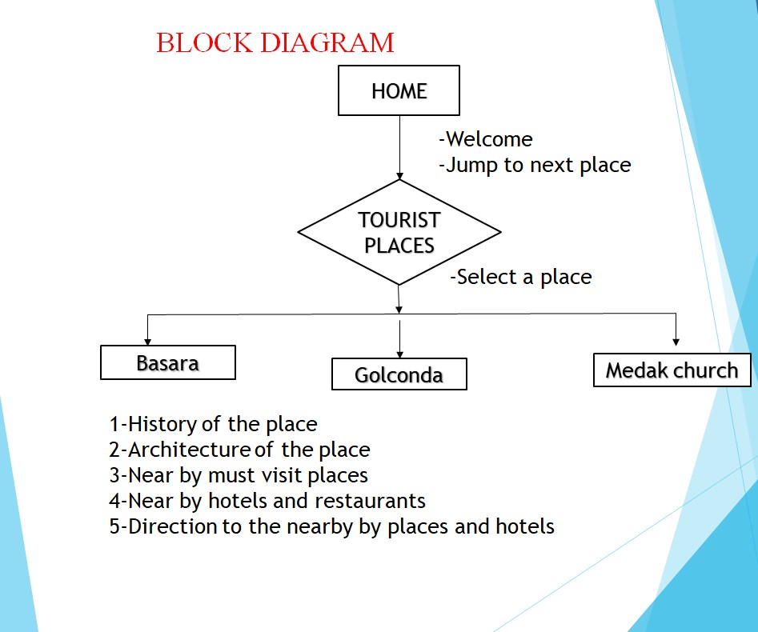

**3.2 REQUIREMENT ANALYSIS**

**3.3.1 Hardware Requirements**

* Desktop/Laptop
* Internet

**3.3.2 Software Requirements**

The Activity class is a crucial component of an Android app, and the way activities are launched and put together is a fundamental part of the platform's application model. Unlike programming paradigms in which apps are launched with a main() method, the Android system initiates code in an Activity instance by invoking specific callback methods that correspond to specific stages of its lifecycle.

This document introduces the concept of activities, and then provides some lightweight guidance about how to work with them. For additional information about best practices in architecting your app, see Guide to App Architecture.

The concept of activities

The mobile-app experience differs from its desktop counterpart in that a user's interaction with the app doesn't always begin in the same place. Instead, the user journey often begins non-deterministically. For instance, if you open an email app from your home screen, you might see a list of emails. By contrast, if you are using a social media app that then launches your email app, you might go directly to the email app's screen for composing an email.

The Activity class is designed to facilitate this paradigm. When one app invokes another, the calling app invokes an activity in the other app, rather than the app as an atomic whole. In this way, the activity serves as the entry point for an app's interaction with the user. You implement an activity as a subclass of the Activities

3. CONTENT PRODIVERS:

A content provider manages access to a central repository of data. A provider is part of an Android application, which often provides its own UI for working with the data. However, content providers are primarily intended to be used by other applications, which access the provider using a provider client object. Together, providers and provider clients offer a consistent, standard interface to data that also handles inter-process communication and secure data access.

Typically you work with content providers in one of two scenarios; you may want to implement code to access an existing content provider in another application, or you may want to create a new content provider in your application to share data with other applications. This topic covers the basics of working with existing content providers. To learn more about implementing content providers in your own applications, see Creating a content provider.

This topic describes the following:

How content providers work.

The API you use to retrieve data from a content provider.

The API you use to insert, update, or delete data in a content provider.

Other API features that facilitate working with providers.

Overview

A content provider presents data to external applications as one or more tables that are similar to the tables found in a relational database. A row represents an instance of some type of data the provider collects, and each column in the row represents an individual piece of data collected for an instance.

A content provider coordinates access to the data storage layer in your application for a number of different APIs and components as illustrated,these include:

Sharing access to your application data with other applications

Sending data to a widget

Returning custom search suggestions for your application through the search framework using SearchRecentSuggestionsProvider

Synchronizing application data with your server using an implementation of AbstractThreadedSyncAdapter

Loading data in your UI using a CursorLoader

Relationship between content provider and other compontents

4:BOARDCAST RECEIVERS

Broadcast receiver is an Android component which allows you to send or receive Android system or application events. All the registered application are notified by the Android runtime once event happens.

It works similar to the publish-subscribe design pattern and used for asynchronous inter-process communication.

For example, applications can register for various system events like boot complete or battery low, and Android system sends broadcast when specific event occur. Any application can also create its own custom broadcasts.

Basics of Broadcast

Let’s discuss some basic concepts of broadcast receiver.

Register Broadcast

There are two ways to register broadcast receiver-

Manifest-declared (Statically) : By this receiver can be registered via the AndroidManifest.xml file.

Context-registered (Dynamically) : By this register a receiver dynamically via the Context.registerReceiver() method.

Receive Broadcasts

To be able to receive a broadcast, application have to extends the BroadcastReceiver abstract class and override its onReceive() method.

If the event for which the broadcast receiver has registered happens, the onReceive() method of the receiver is called by the Android system.

**5) Android studio:**

Android Studio is the official integrated development environment for Google's Android operating system, built on JetBrains' IntelliJ IDEA software and designed specifically for Android development. It is available for download on Windows, macOS and Linux based operating systems or as a subscription-based service in 2020. It is a replacement for the Eclipse Android Development Tools (E-ADT) as the primary IDE for native Android application development.

Android Studio was announced on May 16, 2013 at the Google I/O conference. It was in early access preview stage starting from version 0.1 in May 2013, then entered beta stage starting from version 0.8 which was released in June 2014.The first stable build was released in December 2014, starting from version

On May 7, 2019, Kotlin replaced Java as Google's preferred language for Android app development.Java is still supported, as is C++

Android Studio is a new and fully integrated development environment, which has been recently launched by Google for the Android operating system. It has been designed to provide new tools for app development and to provide an alternative to Eclipse, currently the most widely used IDE.

When you begin a new project in Android studio, the project's structure will appear with almost all the files held within the SDK directory, this switch to a Gradle based management system offers an even greater flexibility to the build process.

Android Studio allows you to see any visual changes you make to your app in real-time, and you can also see how it will look on a number of different Android devices, each with different configurations and resolutions, simultaneously.

Another feature in Android Studio are the new tools for the packing and labelling of code. These let you keep on top of your project when dealing with large amounts of code. The programme also uses a drag & drop system to move the components throughout the user interface.

In addition, this new environment comes with Google Cloud Messaging, a feature which lets you send data from the server to Android devices through the cloud, a great way to send Push notifications to your apps.

The programmer will also help you to localize your apps, giving you a visual way to keep programming while controlling the flow of the application.

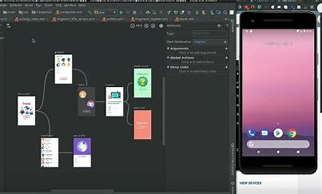

5.**Android virtual device:**

An Android Virtual Device (AVD) is a configuration that defines the characteristics of an Android phone, tablet, Wear OS, Android TV, or Automotive OS device that you want to simulate in the Android Emulator. The AVD Manager is an interface you can launch from Android Studio that helps you create and manage AVDs.

To open the AVD Manager, do one of the following:

Select Tools > AVD Manager.

Click AVD Manager AVD Manager icon in the toolbar.

About AVDs

An AVD contains a hardware

Android Virtual Devices (AVDs) are configurations of emulator options that let you better model an actual device;

A hardware profile. You can set options to define the hardware features of the virtual device. For example, you can define whether the device has a camera, whether it uses a physical QWERTY keyboard or a dialing pad, how much memory it has, and so on.

A mapping to a system image. You can define what version of the Android platform will run on the virtual device. You can choose a version of the standard Android platform or the system image packaged with an SDK add-on.

Other options. You can specify the emulator skin you want to use with the AVD, which lets you control the screen dimensions, appearance, and so on. You can also specify the emulated SD card to use with the AVD.

A dedicated storage area on your development machine, in which is stored the device's user data (installed applications, settings, and so on) and emulated SD card.

You can create as many AVDs as you need, based on the types of devices you want to model and the Android platforms and external libraries you want to run your application on

In addition to the options in an AVD configuration, you can also specify emulator command-line options at launch or by using the emulator console to change behaviors or characteristics at run time. For a complete reference of emulator options, please see the Emulator documentation.

The easiest way to create an AVD is to use the graphical AVD Manager, which you can launch from Eclipse or from the command line using the android tool. The android tool is provided in the tools/ directory of the Android SDK. When you run the android tool without options, it launches the graphical AVD Manager.

For more information about how to work with AVDs from inside your development environment, see Developing in Eclipse with ADT or Developing in Other IDEs, as appropriate for your environment.

This tutorial is intended to explain the Android Virtual Device(AVD).

An Android Virtual Device (AVD) is an emulator configuration that allows developers to test the application by simulating the real device capabilities. We can configure the AVD by specifying the hardware and software options. AVD manager enables an easy way of creating and managing the AVD with its graphical interface. We can create as many AVDs as we need, based on the types of device we want to test for. Below are the steps to create an AVD from AVD manager graphical interface

Go to Window ->AVD Manager and select Virtual Devices.

Click on New to create a Virtual Device, give it some Name and select Target Android Platform from the drop down list

Click “Create AVD” and we are done!

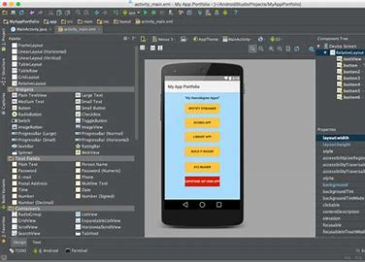

**7) SDK tools:**

Android SDK Tools is a freeware AVD management software download filed under programming software and made available by Google for Windows.

The review for Android SDK Tools has not been completed yet, but it was tested by an editor here on a PC.

Official Google kit provides a set of development and debug tools

SDK Tools is a downloadable component for the Android SDK that includes the complete set of development and debugging tools for the Android SDK. The program enables you to create and test Android applications, enabling you to emulate your Android projects.

Android SDK Tools 31.0.0 on 32-bit and 64-bit PCs

This download is licensed as freeware for the Windows (32-bit and 64-bit) operating system on a laptop or desktop PC from programming software without restrictions. Android SDK Tools 31.0.0 is available to all software users as a free download for Windows.

Documentation

Sign in

Home \ Titanium SDK Titanium SDK Getting Started Installation and Configuration Installing Platform SDKs Installing the Android SDK

The Android SDK Manager installer may be obtained from the Android Studio and SDK tools site.

Required Android Packages

As of Titanium 9.0.0, the build system will automatically download the Android SDK platforms and tools needed.

For Titanium 8.x.x, you need to installed the following packages via the Android SDK Manager yourself:Titanium SDK 7.0.0+ requires Android SDK Tools v25 or newer as a minimum requirement.

Take caution before upgrading these packages, as changes to the way they work has broken the Titanium toolchain a number of times in the past. Although these problems are often beyond our control, we always do our utmost to fix them as soon as we are made aware of them.

With this in mind, it's important to only upgrade these packages between major projects, so that you have time to fix any problems that may result. Always consult the Android Tools Release Notes and Known Issues first, and refer to our Installation Troubleshooting guide to check whether there are any further actions that need to be taken to make the Titanium and the Android SDK compatible.

Android SDK / Target Android platform

Each Titanium SDK supports building against a specific range of Android versions, as shown in the following table, and requires at least one of these versions to be installed. If you specify aandroid:targetSDKVersion in the tiapp.xml file of your project, you must specify one within the target min and max values. The minimum Android/SDK version column indicates the minimum version of Android that a device can run, which a Titanium application support

**Proposed System Architecture**



**CHAPTER 4**

**RESULT**

**4.1 Result**

**4.1.1Home Page:**



**4.1.2 Tourist places:**

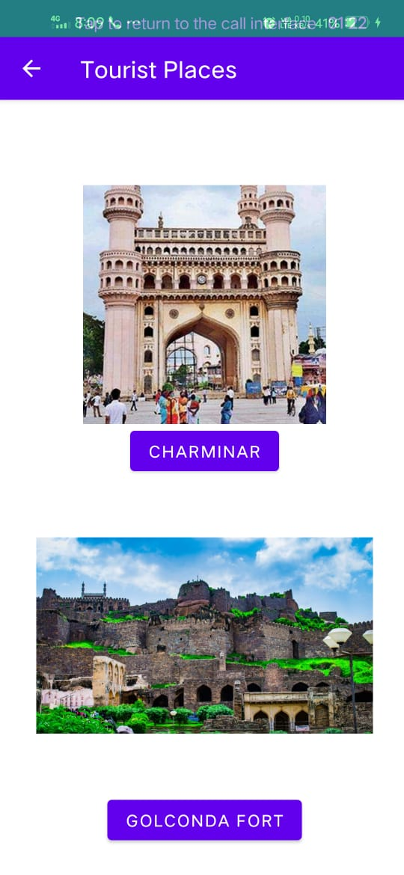

**About the Tourist spot and directions:**

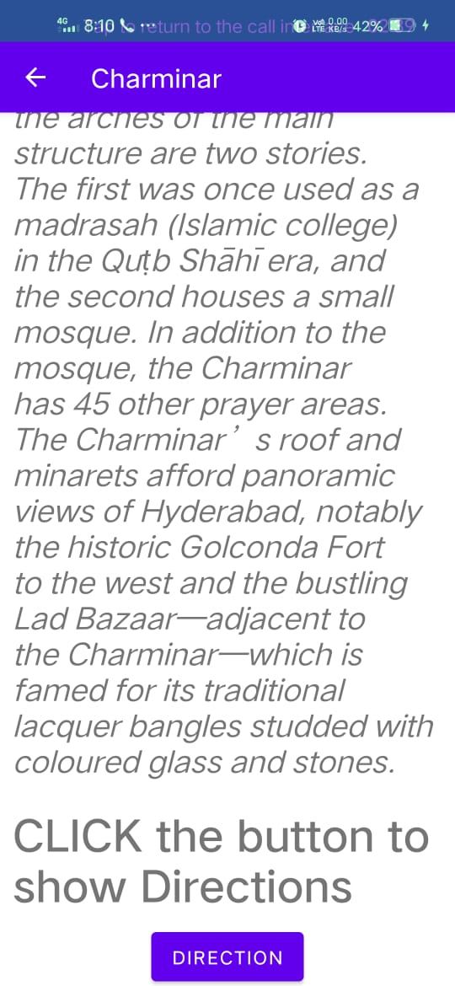

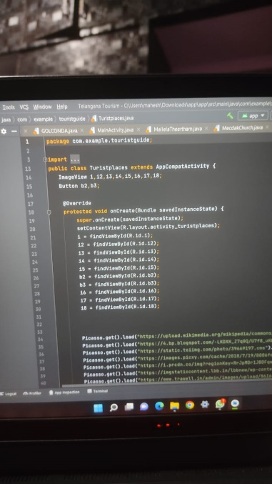 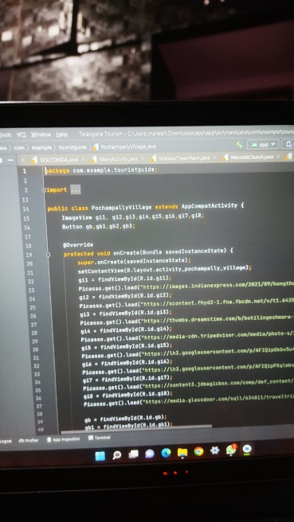 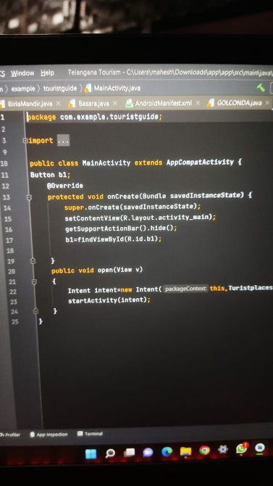

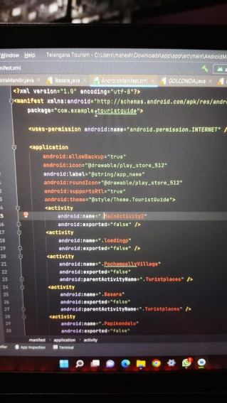 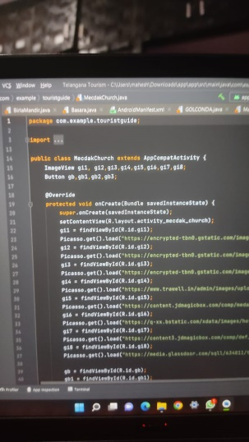 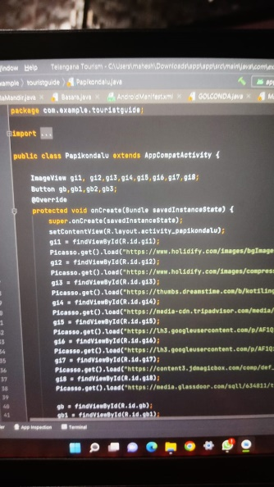

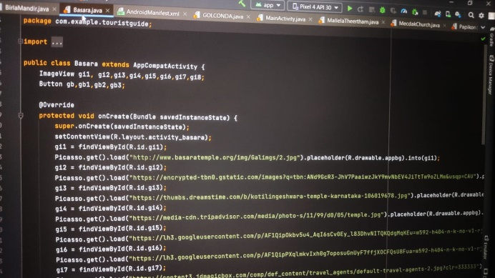

**CHAPTER 5**

**CONCLUSION AND**

**REFERENCES**

**5.1 Conclusion**

* Keeping travelers‟ need in consideration and the current trend to the use of android devices, we have developed our Travel Guide Android Application. The application is able to meet most of the requirements that are commonly asked by travelers, besides, the simplicity of using the application has been maintained. The app can be helpful for Telangana people who are newcomers to Hyderabad city.

**5.2 References**

* https://www.tripadvisor.in/
* https://www.holidify.com/state/telangana/top-destinations-places-to-visit.html
* https://www.telanganatourism.gov.in/
* https://www.trawell.in/telangana